# xpedx.com Next generation

# *News Articles Design Document*

**Authors: Sterling Commerce**

**Date Created:** 04/12/10

**Last Updated:** 7/29/2010 5:47 PM

**File Name:** C:\Documents and Settings\bfurman\My Documents\Temp\Methodology v1.1\Project Management\TEMPLATE - DOCUMENT - Use Case Definition.docxpedx News Articles Detail Design Doc V1.2.docx

Approval Signatures (Mandatory)

|  |  |  |  |  |
| --- | --- | --- | --- | --- |
| **Title** | **Name** | **Signature** | **Date** | **Comments / Issues / Concerns** |
| **xpedx Owner(s)** | Steve Bugher |  |  |  |
| Cheryl Tullis |  |  |  |
| **Sterling Commerce Owner(s)** | Guy Read |  |  |  |
|  |  |  |  |

**Note**: The sign off indicates approval of all sections of the document.

Document Revision History

This chart tracks the changes introduced by the revisions to the document as the project progresses through the stages of the System Development Life Cycle (SDLC).

| Version | **Date** | **Description (Changes Made)** | **Author(s)** |
| --- | --- | --- | --- |
| 0.1 | 04/12/2010 | Initial Draft | Sterling |
| 1.0 | 04/16/2010 | Ready to deliver | Sterling |
| 1.1 | 06/18/2010 | Updated based on feedback dated 2010-06-14 and subsequent clarifications | Sterling |
| 1.2 | 7/29/2010 | Updated with JIRA numbers for issues. | Sterling |

Related or Reference Documents

| Document Name | Description | Owner | Location |
| --- | --- | --- | --- |
| SCI_Xpedx Solution Definition Document v1.5 | Solution Definition document | Sterling Commerce |  |
|  |  |  |  |

TABLE OF CONTENTS

1. Introduction 4

1.1 Document Purpose 4

1.2 Document Audience 4

2 News Articles 5

2.1 Functions & Solution 5

2.1.1 Company News 5

2.1.2 Customer News 5

2.1.3 Structure of a News Article 6

2.2 News Article Screens 6

2.2.1 News Articles List Page (Admin) 6

2.2.2 Create Article Page 6

2.2.3 Edit Article Page 7

2.2.4 News Articles List Page (User) 7

2.2.5 News Article Detail Page 7

2.3 Master System 8

2.4 Implementation Details 8

2.4.1 Entity objects. 8

2.4.2 Actions involved and Functions 8

2.5 Process Flow 8

2.6 Screen Shot 9

2.7 Open Questions 13

2.8 Assumptions 13

3 Glossary of Terms 14

# Introduction

## Document Purpose

This document is the governing functional design document for the News Articles functionality. It presents significant decisions and constructs used in developing the functionality. Testing, builds, configuration management are not covered in this document.

The document will also serve the purpose of keeping a list of assumptions that were made during design discussions.

## Document Audience

This document is intended for management and technical staff working on this project, xpedx IT and Business, webMethods, Legacy(MAX and ACCESS), HP, IW, xpedx/IP Network Team. Sterling will use the document during design and configuration for design consideration.

# News Articles

## Functions & Solution

News articles are a way for xpedx to facilitate communication with customers about site changes and company information. News articles can be text on the website or links to documents or forms. Typical examples would include the following: holiday hours, website availability schedules, policies and procedures, product file downloads, links to surveys or database collections, etc.

News articles are automatically displayed to the target audience on the start date defined for the article and are not displayed to the target audience after the end date defined for the article.

News articles come in two flavours

1. ***Company news*** – these are xpedx managed articles that are published to customers based on their division.
2. ***Customer news*** – these are articles managed by customers and are used for intra-customer communication and will display for all accounts associated with the customer.

There is also a third type – ***Syndicated news articles*** that show up on the customer home page based on attributes such as industry, segment, etc. This is handled outside of Sterling. A Change Request has been initiated (PCR 314) by xpedx to handle this within Sterling.

## Company News

Also known as General news, is managed by CSRs using the Sterling Call Center Application. These allow authorized internal user to post articles. Once posted these articles are visible to all users in the system, internal or external, that are tied to the division.

The functions to be supported for the news articles administration are -

1. Create news articles
2. Edit articles
3. Delete articles
4. Support for attachments – This will be handled as a link to a document/collateral placed on a content server.

## Customer News

Customer news is managed by Customer administrators that have access to the management screens via the web channel. Once posted and active (based on start date), the articles are visible to all the users of the customer as well as to internal user that are tied to the customer. These appear in the Customer Announcements section on the homepage, when a user logs in.

Additionally, customer news articles have a “Force Message” flag - on the article. If an article is setup with the flag turned on and when a user logs in, this article is displayed and the user has to acknowledge the message (Close or Print) to get to the site. Once a user has acknowledged the article, it will not display again for that user.

The functions to be supported for Customer news include

1. Create news articles
   1. Forced Message Flag
2. Edit articles
3. Delete articles

## Structure of a News Article

Company News articles have the following fields (all mandatory)

1. Title
2. Start Date
3. End Date
4. Divisions at which the news article is to be shown – a multi select list
5. Article Body

Customer News articles have the following fields (all mandatory)

1. Title
2. Start Date
3. End Date
4. Force Read Option – default to No.
5. Article Body

## News Article Screens

The list of all pages related to News Articles Administration/Viewing

1. News Articles List Page (Admin)
2. Create Article Page
3. Edit Article Page
4. News Article List Page (User)
5. News Article Detail Page

## News Articles List Page (Admin)

This page displays all the News Articles that the user (internal/external) has access to. The following fields will be shown as column headers on the List page, and the columns headers are sort able. Please refer to ‘News Article List Page (Admin)’ in the Screen Shot section of the document.

1. Title
2. Start
3. End Date
4. Last Modified Date

Actions – The following actions are permitted at the List level

1. Create News Article
2. Edit News Article
3. Delete News Article

## Create Article Page

Once a user has chosen to create a new article, she/he is on the Create Article Page. This page displays the details of a particular news article. Users will be able to create and publish an article from within this screen.

The mandatory data elements to create Company News vs Customer News vary slightly and are detailed in the section “Structure of a News Article”.

The following actions can be performed on the Create Article Page.

1. Add title/start date/end date and article text
2. Choose whether this is a Forced Message (Customer news only)
3. Select the list of divisions where this article is active (Company news only)
4. Publish the article
5. Abandon the create article process.

## Edit Article Page

From the “News Article List Page (Admin)” a user may edit news articles. This page is displayed when edit is selected. This screen is similar to the create article screen with the data from an existing article prepopulated. The user has the option to change any of the existing fields on a article such as title/start date/end date/article body.

The following actions can be performed on the Edit Article Page.

1. Edit title/start date/end date and article text
2. Change whether this is a Forced Message (Customer news only)
3. Change the list of divisions where this article is active (Company news only)
4. Accept or abandon the changes.
5. Delete article.

## News Articles List Page (User)

This page displays all the News Articles that the customer user can view. This list contains only the articles that are currently active. The following fields will be shown as column headers on the List page, and the columns headers are sort able. Please refer to ‘News Article List Page’ in the Screen Shot section of the document.

1. Title
2. Last Modified Date

The only action that a user may perform is to view the details of a news article from the list

## News Article Detail Page

From the “News Article List Page (User)” a user may view the details of news articles. This page is displayed when view is selected. It displays the article details such as Title/Last update date and Body.

The only action that can be performed on this page is to return to the list of active news articles.

## Master System

Sterling is the master of system to maintain and create News Articles.

## Implementation Details

## Entity objects.

## Actions involved and Functions

## Process Flow

## Screen Shot

The screen shots pasted here are still in review and not final. This is just an illustration of how it looks today.

***Company News Articles List Page (Admin)***

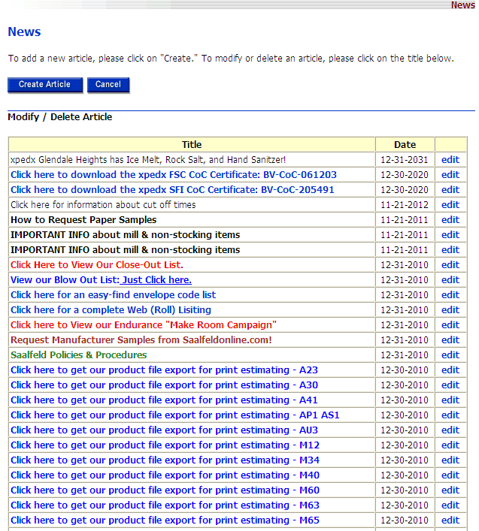

***Create Company News Article Page***

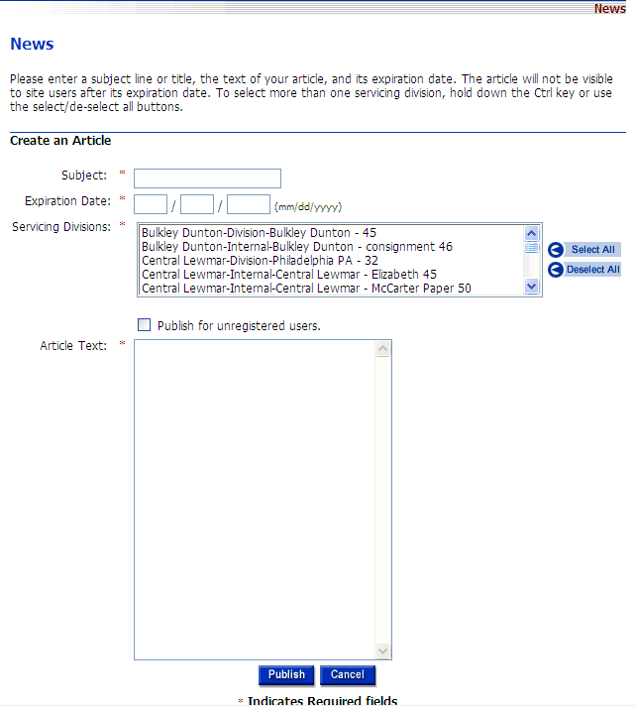

***Edit Company News Article Page***

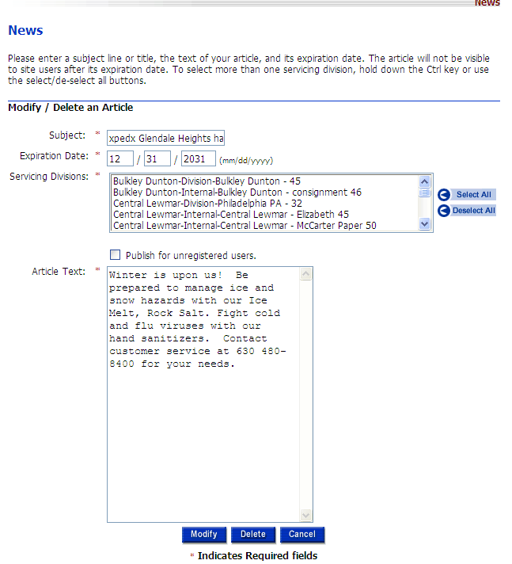

***Company News Articles List Page (User)***

[TBD]

***Company News Article Detail Page***

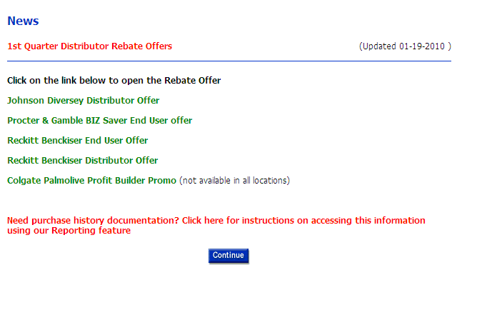

***Customer News Article List Page (Admin)***

***Customer News Article Create Page***

***Customer News Article Edit Page***

***Customer News Article List Page (User)***

***Customer News Article Detail Page***

## Open Questions

1. Rich Text editor on orderline customer news – is this a requirement for BR1 ? [Steve B. – 20100426 - can wait for BR 2]. [Cheryl T – 7/28 – This is not a priority task for BR1, but would like to see it done. Issue being tracked in JIRA 319.
2. Forced read flag reset – is this a requirement for BR1 ? The use case discussed was around the fact that there are several cases where a supervisor logs in on behalf of the user and if the force read message was acknowledged, then the next time the user logged in, they never see the message. so the desired functionality was that the message could be marked as “unread” for the user. [Steve B. 20100426 – BR2 req.]. [ Cheryl T – 7/28 – This also needs to be done for BR1, but is not a priority task. Issue being tracked in JIRA 345]
3. Locale – On orderline, each article has a locale associated to it. The customer records in NG have a locale = “en_US”. Do we need this locale based filtering? [Steve B. – 20100426 - ? In BR 2 we will to drive the language the article is displayed]
4. Customer news – do we need to support attachments ? If yes, can they be the same way as we do for Company News. [Steve B. – 20100429 - We should be able, but would like to review solution]. [Steve 20100615 - Hosted on content server and linked to it in the article.]
5. OrderLine has a “preview” news article button – do we have a requirement to support this? [Steve B. – 20100615 - For BR1 we have a “Publish” button that saves the article. The article is published only after the start date.]
6. Can an internal user create a customer specific news article? If yes, what does the UI look like? [Steve B. – 20100426 - Yes, UI would be same as customer creating it.]
7. UI for Forced Articles. [Prashant – 20100615 – Based on (2) above, not required for BR1]
8. Purge mechanism/timing.
9. Syndicated news articles – process and flow. [Steve B. – 20100615 - “What they think” section on today’s site. Today is pulled from “what they think” site. Possible solution - Quick Links section. Being handled as a CR - 314] . [Steve B – 7/28 – This is a requirement for BR1 and the requirements/flow are being tracked as part of JIRA 314]
10. Content Server – how will content get posted onto server and referenced in Sterling articles?
11. [Steve – 6/15/2010 - Not required to do segment based targeting.]
12. Do we have news displaying on the home page ? [ Steve B. – 20100615 - Yes. Split into two sections (customer / xpedx). Display total # of articles that a customer would see in View All. No need for carousel.]
13. News Maintenance - How do we land on this view? [Steve - 20100615 - There will be a link under the admin tab to maintain news. Tools tab will have the view all link.]
14. What do we want the character length to be for the description showing on View All (v2) ? [Steve/George 20100615 - 500 chars.]
15. For view all - which date shows up after the title? [Jasmine - 20100615 - Start date]
16. [Cheryl T. – 20100423 - Can hyperlinks be selected for news articles?] [Prashant – 20100617 – Yes. We can add as many hyper links as needed to the body of the news article.]

## Assumptions

1. xpedx will provide the final screenshots for the pages listed in the screen shots section. Currently we’re using the existing dotcom pages as placeholders to capture the key data elements.
2. All Company news articles created by an internal user are visible to internal users.
3. Customer news articles are only visible to the customer users and to internal users associated with the customer.
4. All resources (attachments, images, etc.) are maintained on a content server and referenced via hyper links in articles.
5. Customers will not be able to upload any images/attachments to the website. The process to reference these is similar to the process used to reference resources described above.
6. There is no support for intra-company news articles.

# Glossary of Terms

|  |  |  |
| --- | --- | --- |
| S. No. | Term | Definition |
| 1. | Content Server | A server that hosts all the collateral such as images, specification sheets, etc. |
| 2. | BR1 | Business Release 1 |
| 3. | IW | Industrial Wisdom – UI firm engaged on the project. |
|  |  |  |